**Week - 7**

1. **Aim** : Create a Form using HTML

**Code :**

<html>

<body bgcolor="lightblue">

<h2 align="center" > Fill the Below Form for Resume </h2>

<form>

First Name : <input type = "text" name = "fn" / >

Last Name : <input type = "text" name = "ln" />

<br>

Father's Name :<br> <input type = "text" name = "fn"/>

<br>

Mother's Name :<br> <input type = "text" name = "mn" />

<br>

Date of Birth : <br>

Date : <input type = "text" name = "password" />

Month : <input type = "text" name = "password" />

Year : <input type = "text" name = "password" />

<br>

Email :<br> <input type = "text" name = "text" />

<br>

Phone Number :<br> <input type = "text" name = "password" />

<br>

Address :<br> <input type = "text" name = "password" />

<p> Gender : </p>

<input type = "radio" name = "subject" value = "Male"> Male

<input type = "radio" name = "subject" value = "Female"> Female

<input type = "radio" name = "subject" value = "Others"> Others

<p> Intrests : </p>

<input type = "checkbox" name = "Software development" value = "on"> Software development <br>

<input type = "checkbox" name = "Data analysis" value = "on"> Data analysis <br>

<input type = "checkbox" name = "Network security" value = "on"> Network security <br>

<input type = "checkbox" name = "Computer hardware" value = "on">Computer hardware <br>

<p> Programming Languages : </p>

<input type = "checkbox" name = "C" value = "on"> C <br>

<input type = "checkbox" name = "C++" value = "on"> C++<br>

<input type = "checkbox" name = "Python" value = "on"> Python<br>

<input type = "checkbox" name = "Java"value = "on"> Java <br>

<p> Hobbies : </p>

1.<input type = "text" name = "text" /> <br>

2.<input type = "text" name = "text"/> <br>

3.<input type = "text" name = "text" /> <br>

4.<input type = "text" name = "text" /> <br>

<p> Achievement :</p>

1.<input type = "text" name = "text" /> <br>

2.<input type = "text" name = "text"/> <br>

3.<input type = "text" name = "text" /> <br>

4.<input type = "text" name = "text" /> <br>

</form>

<br>

<input type="submit" value="Submit">

<input type="Reset" value="Reset">

</body>

</html>

**OUTPUT:**

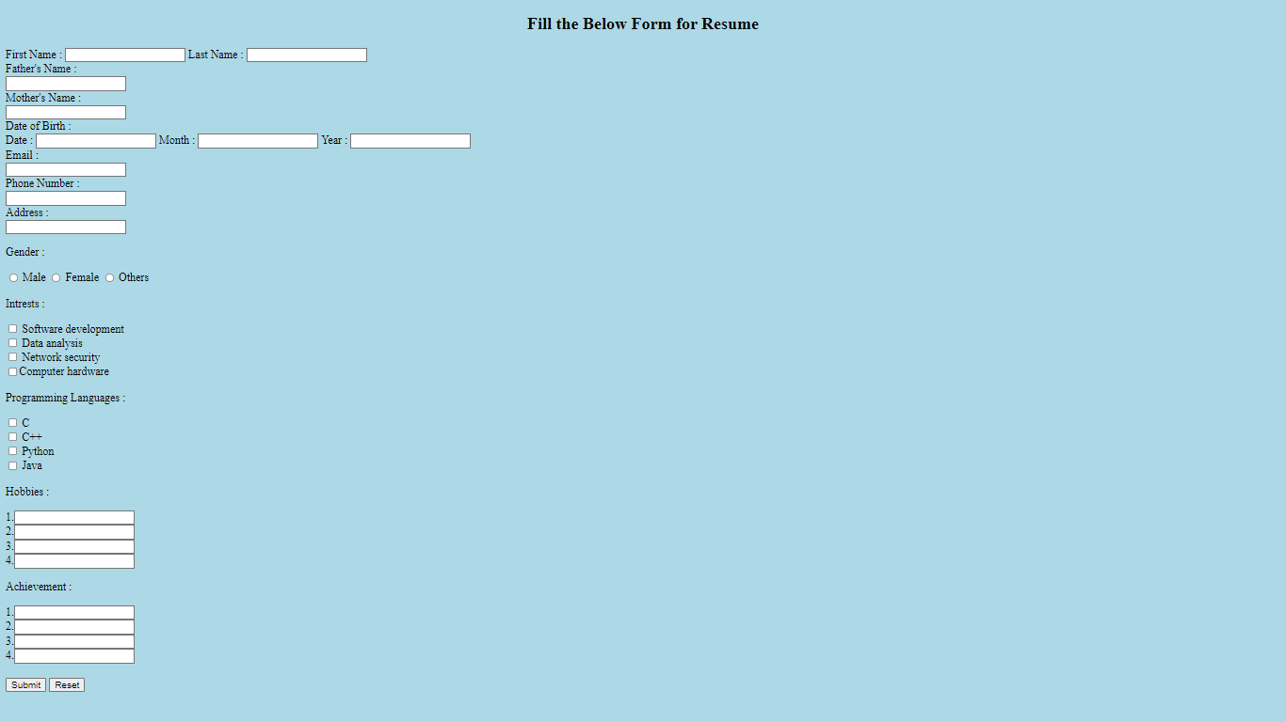

**Week - 8**

**1.Aim :** Create a website using HTML.

CODE:

|  |
| --- |
| <html lang="en"> |
|  |  |
|  | <head> |
|  | <meta charset="UTF-8"> |
|  | <meta http-equiv="X-UA-Compatible" content="IE=edge"> |
|  | <meta name="viewport" content="width=device-width, initial-scale=1.0"> |
|  | <link rel="apple-touch-icon" sizes="180x180" |
|  | href="<https://media.istockphoto.com/vectors/ransomware-icon-vector-on-white-background-ransomware-trendy-filled-vector-id1095638720>" /> |
|  | <link rel="icon" type="image/png" sizes="32x32" |
|  | href="<https://media.istockphoto.com/vectors/ransomware-icon-vector-on-white-background-ransomware-trendy-filled-vector-id1095638720>" /> |
|  | <link rel="icon" type="image/png" sizes="16x16" |
|  | href="<https://media.istockphoto.com/vectors/ransomware-icon-vector-on-white-background-ransomware-trendy-filled-vector-id1095638720>" /> |
|  | <style> |
|  | @import url('https://fonts.googleapis.com/css2?family=Poppins:wght@100;200;300;400;500;600;700;800;900&display=swap'); |
|  |  |
|  | @import url('https://fonts.googleapis.com/css2?family=Supermercado+One&display=swap'); |
|  |  |
|  | * { |
|  | margin: 0; |
|  | padding: 0; |
|  | box-sizing: border-box; |
|  | font-family: 'Poppins', sans-serif; |
|  | } |
|  |  |
|  |  |
|  | .heading { |
|  | text-align: center; |
|  | margin: 25px 0; |
|  | font-family: 'Supermercado One', cursive; |
|  | font-size: 43px; |
|  | } |
|  |  |
|  | .headingsecond { |
|  | text-align: center; |
|  | margin: 20px 0; |
|  | font-family: 'Supermercado One', cursive; |
|  | font-size: 25px; |
|  | } |
|  |  |
|  | nav { |
|  | display: flex; |
|  | padding: 50% 50% justify-content: space-between; |
|  | align-items: center; |
|  |  |
|  | background-color: #FFC300; |
|  | font-family: "Montserrat", sans-serif; |
|  | } |
|  |  |
|  | .nav-links { |
|  | flex: 1; |
|  | text-align: right; |
|  |  |
|  | } |
|  |  |
|  | .nav-links ul li { |
|  | list-style: none; |
|  | display: inline-block; |
|  | padding: 9px 12px; |
|  | position: relative; |
|  | font-size: 20px; |
|  | font-weight: 200; |
|  | } |
|  |  |
|  | .nav-links ul li a { |
|  | color: #fff; |
|  | text-decoration: none; |
|  | font-size: 20px; |
|  | ; |
|  | } |
|  |  |
|  | .nav-links ul li::after { |
|  | content: ''; |
|  | width: 0%; |
|  | height: 2px; |
|  | display: block; |
|  | background: #f44336; |
|  | margin: auto; |
|  |  |
|  | } |
|  |  |
|  | .nav-links ul li:hover::after { |
|  | width: 100%; |
|  | } |
|  |  |
|  |  |
|  | .headingthird { |
|  | color: white; |
|  | text-transform: uppercase; |
|  | letter-spacing: 5px; |
|  | font-size: 25px; |
|  | margin-left: 20px; |
|  | } |
|  |  |
|  |  |
|  | .content { |
|  | font-size: 20px; |
|  | padding: 20px; |
|  | background: #40E0D0; |
|  | background: -webkit-linear-gradient(to right, #FF0080, #FF8C00, #40E0D0); |
|  | background: linear-gradient(to right, #FF0080, #FF8C00, #40E0D0); |
|  | -webkit-text-fill-color: transparent; |
|  | -webkit-background-clip: text; |
|  | font-weight: 500; |
|  | } |
|  |  |
|  | .box { |
|  | display: grid; |
|  | grid-template-columns: 1fr 1fr; |
|  | column-gap: 20px; |
|  | justify-content: center; |
|  | align-items: center; |
|  | margin: 20px 40px; |
|  | } |
|  |  |
|  | .hero-img { |
|  | display: block; |
|  | margin-left: auto; |
|  | margin-right: auto; |
|  | width: 380px; |
|  | border-radius: 10px; |
|  | } |
|  |  |
|  | button { |
|  | display: inline-block; |
|  | background-color: #D8C09A; |
|  | border-radius: 10px; |
|  | border: 4px double #cccccc; |
|  | color: #eeeeee; |
|  | text-align: center; |
|  | font-size: 21px; |
|  | padding: 7px; |
|  | width: 235px; |
|  | -webkit-transition: all 0.5s; |
|  | -moz-transition: all 0.5s; |
|  | -o-transition: all 0.5s; |
|  | transition: all 0.5s; |
|  | cursor: pointer; |
|  | margin: 8px; |
|  | } |
|  |  |
|  | button a { |
|  | text-decoration: none; |
|  | color: black; |
|  | } |
|  |  |
|  | button { |
|  | border-radius: 10px; |
|  | } |
|  |  |
|  | button:hover { |
|  | background-color: green; |
|  | } |
|  |  |
|  |  |
|  | .footer { |
|  | background: #1193DA; |
|  | color: white; |
|  | padding: 1rem; |
|  | } |
|  |  |
|  | .grid-wrap { |
|  | display: grid; |
|  | grid-template-columns: repeat(4, 1fr); |
|  | margin: 10px 10%; |
|  | } |
|  | .flex { |
|  | display: flex; |
|  | flex-direction: column; |
|  | } |
|  | .heading-foot { |
|  | font-weight: bold; |
|  | text-transform: uppercase; |
|  | margin: 20px 0; |
|  | font-size: 1.2rem; |
|  | } |
|  | .col a { |
|  | text-decoration: none; |
|  | color: white; |
|  | text-transform: capitalize; |
|  | padding: 5px 0; |
|  | } |
|  | .end-line { |
|  | display: flex; |
|  | justify-content: space-around; |
|  | background: black; |
|  | color: white; |
|  | padding: 2rem; |
|  | } |
|  |  |
|  | .logo { |
|  | text-transform: uppercase; |
|  | /* font-weight: bold; */ |
|  | font-size: 1.8rem; |
|  | } |
|  | .copy { |
|  | text-transform: capitalize; |
|  | text-align: center; |
|  | } |
|  |  |
|  | .social i { |
|  | font-size: 1.5rem; |
|  | padding: 0 20px; |
|  | color: white; |
|  | } |
|  |  |
|  | .centering { |
|  | display: flex; |
|  | justify-content: center; |
|  | align-items: center; |
|  | } |
|  |  |
|  | .fa-facebook-f:hover { |
|  | color: #3a559f; |
|  | } |
|  |  |
|  | .fa-instagram:hover { |
|  | color: red; |
|  | } |
|  |  |
|  | .fa-linkedin:hover { |
|  | color: #0274b3; |
|  | } |
|  |  |
|  | .fa-twitter:hover { |
|  | color: #01a2ed; |
|  | } |
|  |  |
|  | ul.nysr { |
|  | width: 100%; |
|  | flex-direction: row; |
|  | display: flex; |
|  | flex-wrap: nowrap; |
|  | align-items: stretch; |
|  | list-style: none; |
|  | padding-inline-start: 0; |
|  | } |
|  |  |
|  | li.single-nysr { |
|  | width: 25%; |
|  | margin-left: 10px; |
|  | margin-right: 10px; |
|  | background-color: #f5f5f5; |
|  | text-align: left; |
|  | border: 1px solid #c9c9c9; |
|  | border-radius: .25rem; |
|  | } |
|  |  |
|  | li.single-nysr:first-child { |
|  | margin-left: 0; |
|  | } |
|  |  |
|  | li.single-nysr:last-child { |
|  | margin-right: 0; |
|  | } |
|  |  |
|  | footer p { |
|  | margin: 4rem auto 1rem auto; |
|  | font-size: 1.1rem; |
|  | } |
|  |  |
|  | video.center { |
|  | display: block; |
|  | margin-left: auto; |
|  | margin-right: auto; |
|  | } |
|  |  |
|  | header { |
|  | display: flex; |
|  | justify-content: space-around; |
|  | align-items: center; |
|  | padding: 17px; |
|  | } |
|  |  |
|  |  |
|  | .nav-links li a { |
|  | text-decoration: none; |
|  | padding: 0 30px; |
|  |  |
|  | } |
|  |  |
|  | .nav-links li { |
|  | list-style-type: none; |
|  |  |
|  | } |
|  |  |
|  | .nav-links { |
|  | margin-left: 65%; |
|  | display: flex; |
|  | justify-content: space-between; |
|  |  |
|  | } |
|  |  |
|  | </style> |
|  | <title>Ransomware</title> |
|  | </head> |
|  |  |
|  | <body bgcolor="azure"> |
|  | <nav> |
|  | <header> |
|  | <div class='headingthird'> |
|  | <h3>Ajay Cybersecurity Guides</h3> |
|  | </div> |
|  | <div> |
|  | <ul class='nav-links'> |
|  | <li><a href="[#home](https://cyberthreats.ajaykumarvarma.live/ransomware.html#home)">Home</a></li> |
|  | <li><a href="[#news](https://cyberthreats.ajaykumarvarma.live/ransomware.html#news)">News</a></li> |
|  | <li><a href="<https://t.me/ajayownerofhg>">Contact</a></li> |
|  | <li><a href="[#about](https://cyberthreats.ajaykumarvarma.live/ransomware.html#about)">About</a></li> |
|  | </ul> |
|  | </div> |
|  | </nav> |
|  | </header> |
|  | <h1 class="heading">Ransomware</h1> |
|  |  |
|  | <div class="box"> |
|  | <p class="content"> |
|  | Ransomware is a type of malicious software, or malware,that prevents you from accessingyour computer files, |
|  | systems, or networks and demands you pay a ransom for their return. Ransomware attacks can |
|  | cause costly disruptions to operations and the loss of critical information and data. |
|  | </p> |
|  |  |
|  | <img class="hero-img" |
|  | src="<https://media.gettyimages.com/illustrations/lock-abstract-glitch-background-illustration-id1291279260?s=612x612>" /> |
|  |  |
|  | <br> |
|  | </div> |
|  | <h1 class="heading">Some Ransomware Attacks</h1> |
|  | <div class="box"> |
|  |  |
|  | <p class="content">WannaCry: A powerful Microsoft exploit was leveraged to create a worldwide ransomware worm |
|  | that infected over 250,000 systems before a killswitch was tripped to stop its spread. Proofpoint was |
|  | involved in finding the sample used to find the killswitch and in deconstructing the ransomware |
|  | </p> |
|  |  |
|  | <img class="hero-img" |
|  | src="<https://images.theconversation.com/files/169334/original/file-20170515-6987-lw7ou2.png?ixlib=rb-1.1.0&q=45&auto=format&w=926&fit=clip>" /> |
|  |  |
|  |  |
|  |  |
|  | </div> |
|  | <br> |
|  | <div class="box"> |
|  | <p class="content"> |
|  | Bad Rabbit:Bad Rabbit presents nothing new in its subtle techniques: it follows the footsteps of WannaCry |
|  | and NotPetya. It has hit organizations mainly in Russia and Eastern Europe disguised as an Adobe Flash |
|  | installation. It spreads via drive-by downloads on compromised websites where it was inserted into HTML code |
|  | or Java files using JavaScript. Once downloaded and installed, the PC is locked. The ransom is $ 280 in |
|  | bitcoin with a 40-hour-deadline. |
|  | </p> |
|  |  |
|  | <img class="hero-img" |
|  | src="<https://encrypted-tbn0.gstatic.com/images?q=tbn:ANd9GcRWKy00ZA3koG6d_8fFXm4P4juw7DVN8hqZvB4llW1uzPiQiQ0UXQWBKKsESpNHMRbGRns&usqp=CAU>" /> |
|  |  |
|  |  |
|  | </div> |
|  | <br> |
|  | <h1 class="heading">How To Prevent Your Computer/Laptop From Ransomwares!</h1><br> |
|  | <h3 class="headingsecond">Watch Video Below !</h3> |
|  | <center> |
|  | <video width="600" height="450" poster="https://i.ytimg.com/vi/SgYYJnE36RA/maxresdefault.jpg " controls> |
|  | <source |
|  | src="<https://cyberthreats.ajaykumarvarma.live/Ransomware%20and%20How%20to%20Prevent%20a%20Ransomware%20Attack%20(2021).mp4>"> |
|  | </video> |
|  | </center> |
|  | <br><br><br> |
|  | <button class="vertical-center" type="button" |
|  | style="background-color:lightblue;margin-right:auto;margin-left:auto;display:block;margin-top:0%;margin-bottom:3%;border:none;padding:10px 12px;"> |
|  | <a href="<https://www.kaspersky.com/resource-center/threats/ransomware>" target="_blank">View More About |
|  | Ransomware!</a> |
|  | </button> |
|  | <br><br> |
|  | <div class="footer"> |
|  | <div class="grid-wrap"> |
|  | <div class="col flex"> |
|  | <p class="heading-foot">Antivirus Softwares</p> |
|  | <a href="<https://www.bitdefender.com/>">Bitdefender</a> |
|  | <a href="<https://www.malwarebytes.com/>">Malwarebytes</a> |
|  | <a href="<https://www.kaspersky.co.in/>">Kaspersky</a> |
|  | <a href="<https://www.mcafee.com/en-in/index.html>">Mcafee</a> |
|  | </div> |
|  | <div class="col flex"> |
|  | <p class="heading-foot">explore</p> |
|  | <a href="[#](https://cyberthreats.ajaykumarvarma.live/ransomware.html)">community</a> |
|  | <a href="[#](https://cyberthreats.ajaykumarvarma.live/ransomware.html)">blog</a> |
|  | <a href="[#](https://cyberthreats.ajaykumarvarma.live/ransomware.html)">Older Version</a> |
|  | </div> |
|  | <div class="col flex"> |
|  | <p class="heading-foot">AJAY</p> |
|  | <a href="<https://webprogramming.ajaykumarvarma.live/web%20programming/week4-web-resume-3frames/index.html>">about me</a> |
|  | <a href="[#](https://cyberthreats.ajaykumarvarma.live/ransomware.html)">faq</a> |
|  | <a href="[#](https://cyberthreats.ajaykumarvarma.live/ransomware.html)">contact us</a> |
|  | </div> |
|  | <div class="col flex"> |
|  | <p class="heading-foot">legal</p> |
|  | <a href="[#](https://cyberthreats.ajaykumarvarma.live/ransomware.html)">privacy policy</a> |
|  | <a href="[#](https://cyberthreats.ajaykumarvarma.live/ransomware.html)">terms & conditions</a> |
|  | </div> |
|  | </div> |
|  | </div> |
|  | <div class="end-line"> |
|  | <p class="logo">AJAY</p> |
|  | <p class="copy centering">&copy; AJAY CYBERSECURITY GUIDES 2022. All rights reserved</p> |
|  | <div class="social centering"> |
|  | <a href="[#](https://cyberthreats.ajaykumarvarma.live/ransomware.html)"><i class="fab fa-facebook-f"></i></a> |
|  | <a href="<https://www.instagram.com/ajaykumarvarma_32/>"><i class="fab fa-instagram"></i></a> |
|  | <a href="<https://www.linkedin.com/in/nagaraju-ajay-kumar-varma-4b0449228/>"><i class="fab fa-linkedin"></i></a> |
|  | <a href="[#](https://cyberthreats.ajaykumarvarma.live/ransomware.html)"><i class="fab fa-twitter"></i></a> |
|  | </div> |
|  | </div> |
|  | <br> |
|  | </body> |
|  |  |
|  | </html> |

Output ss:

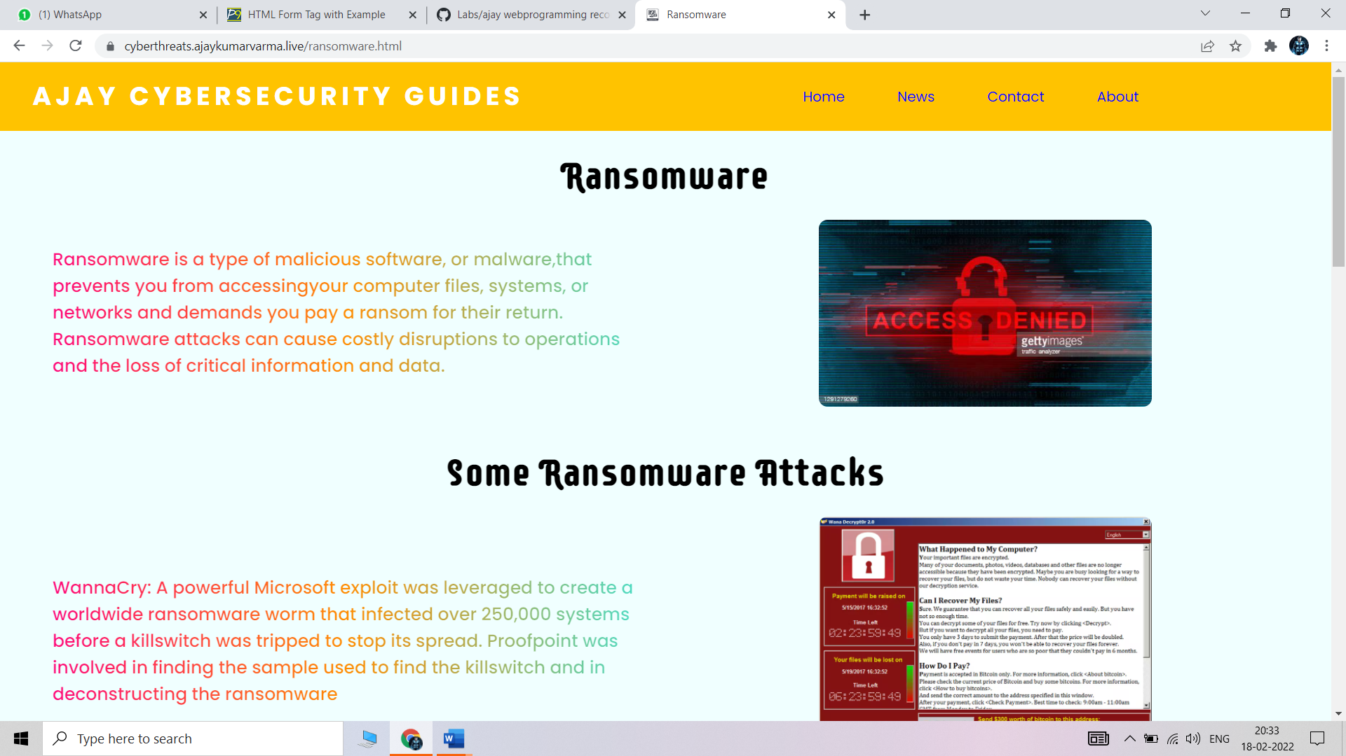

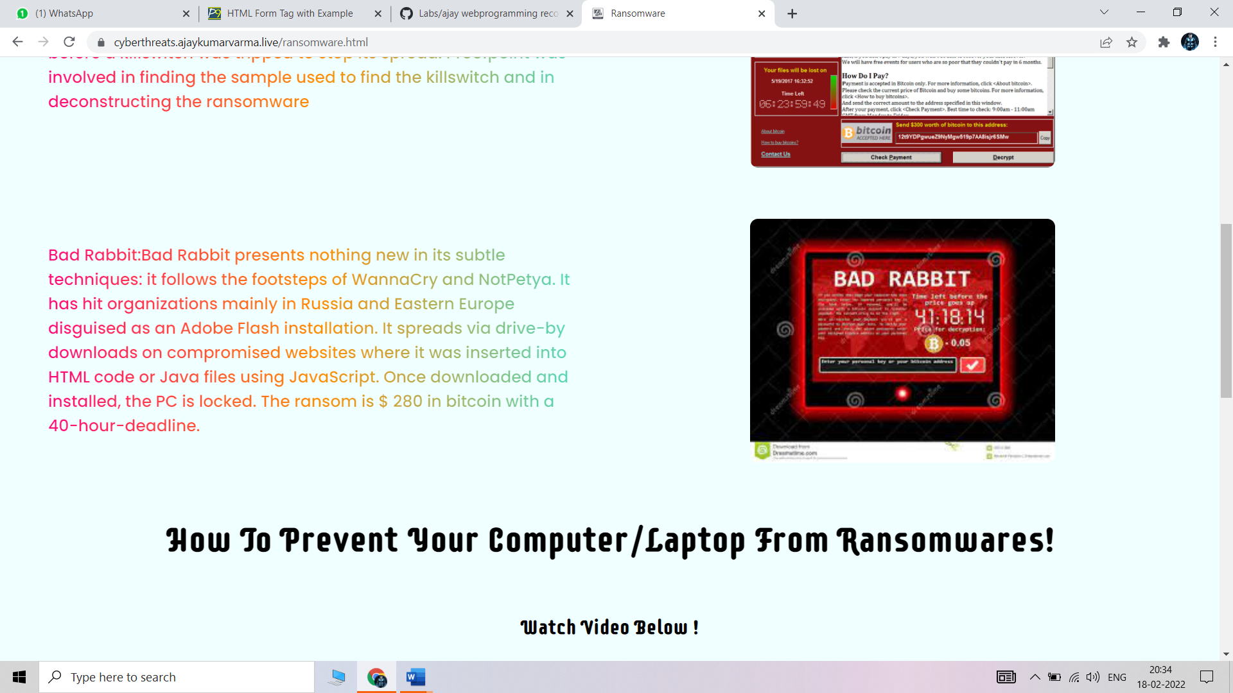

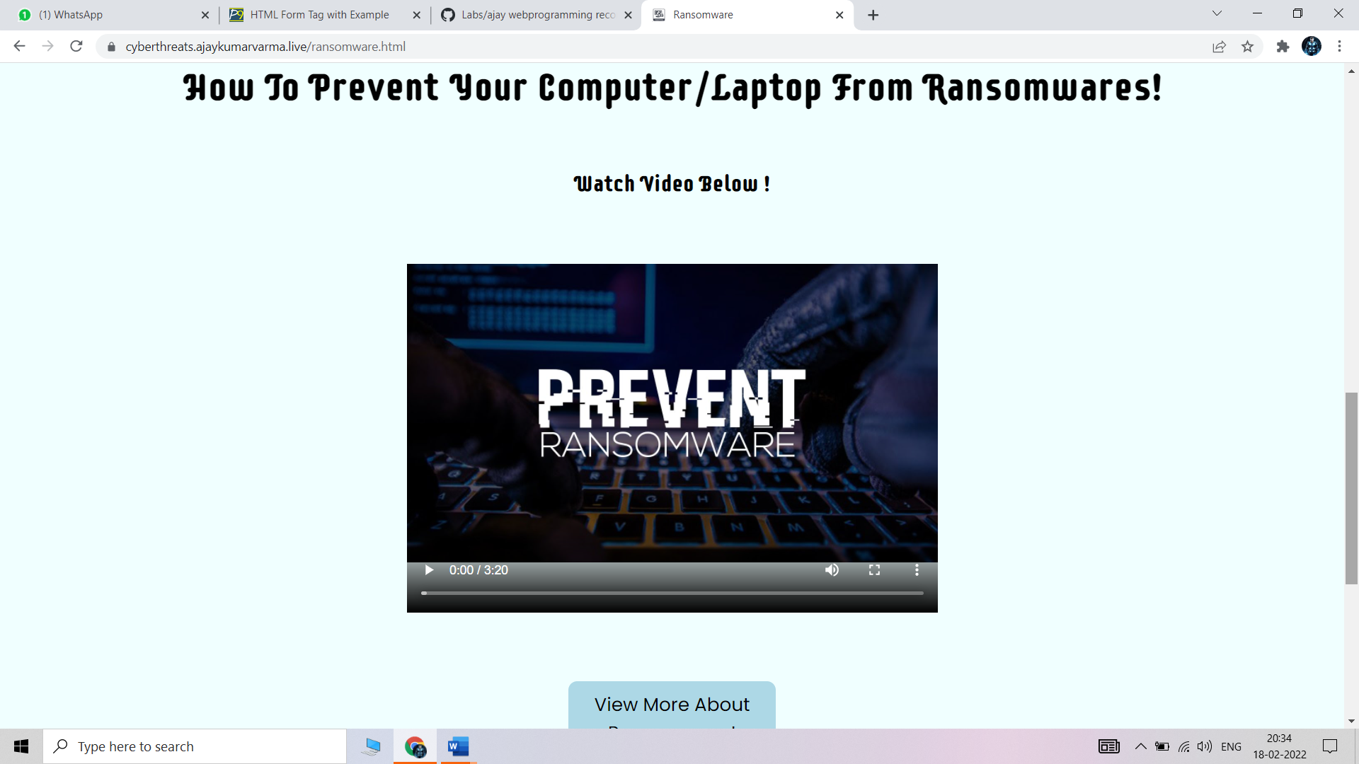

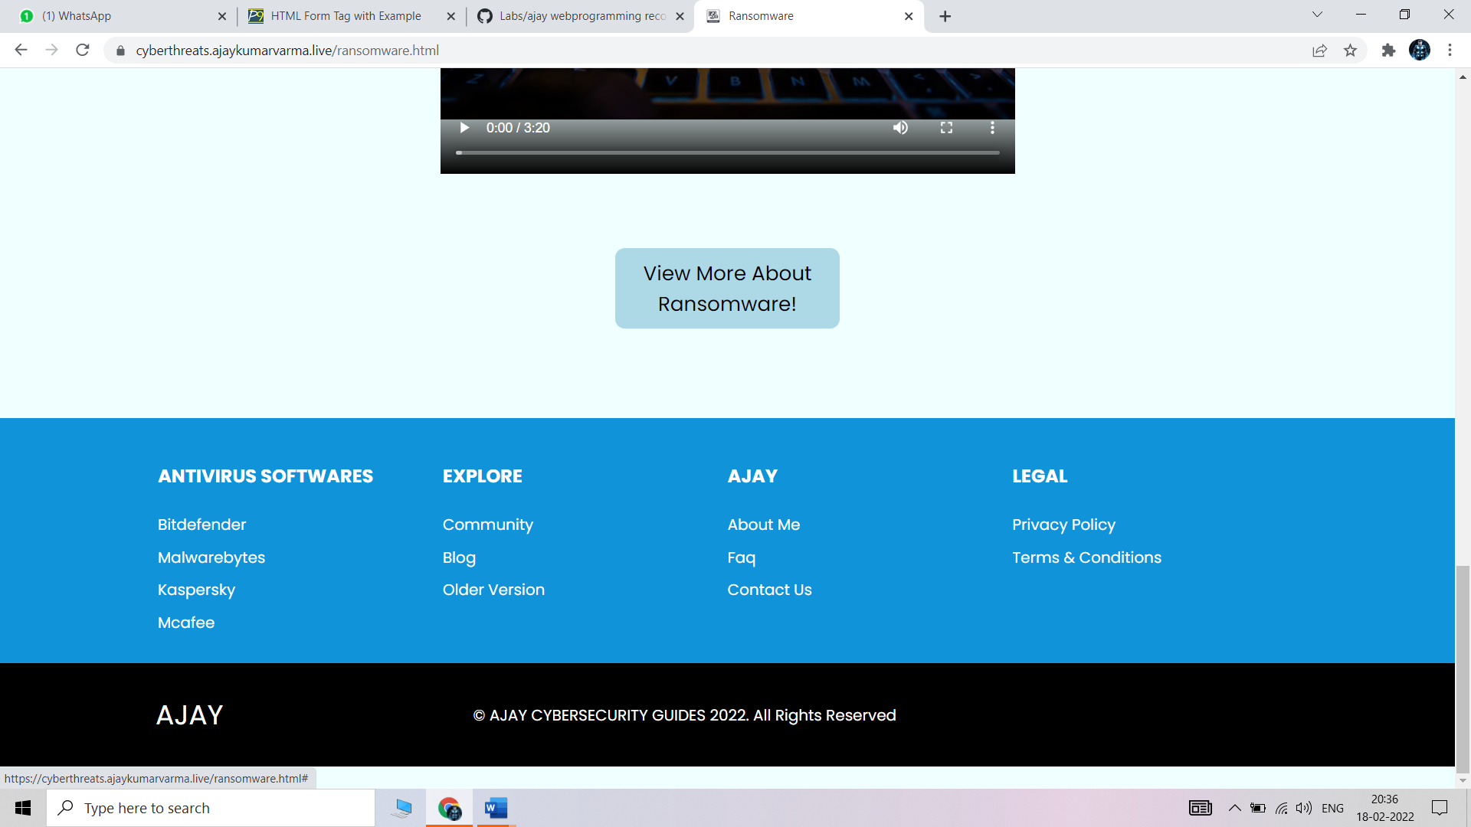

# **Week - 9**

# 1.What is Django, what is the framework that is used to implement Django.

## **DJANGO**

## Django is a high-level Python web framework that encourages rapid development and clean, pragmatic design. Built by experienced developers, it takes care of much of the hassle of web development, so you can focus on writing your app without needing to reinvent the wheel. It’s free and open source.

## Ridiculously fast.

## Django was designed to help developers take applications from concept to completion as quickly as possible.

## Reassuringly secure.

## Django takes security seriously and helps developers avoid many common security mistakes.

## Exceedingly scalable.

## Some of the busiest sites on the web leverage Django’s ability to quickly and flexibly scale.

## 

# **FRAMEWORK**

## Rich ecosystem

## Read Django like a system, developers say. What they mean is that there are many third-party applications that come with Django. These applications can be integrated depending on project requirements. To imagine this better, think of Legos. There are many different Lego blocks. In app development, an authorization “block” or email sending “block” is present in almost every project. Django consists of many applications — such as for authorization and sending emails — that can easily be plugged into a system.

## Maturity. Django has been around for 11 years and has gone through stages of significant improvement. A lot of things have been brought to perfection and many new things have been added. Most importantly, when you’re trying to figure out how something should work in Django, you can usually find the answer. Thousands of people must have already solved any issue you’re dealing with, and you can find a solution provided by the passionate Django community.

## Admin panel by default

## Admin panels are designed to help you manage your application. A Django admin panel is generated automatically from Python code, whereas creating an admin panel manually would take a lot of time and be absolutely pointless.

## There’s a lot of room for customization in the Django admin panel thanks to third-party applications. Additionally, Django allows you to modify the interface with third-party wrappers and add dashboards unique to your needs.

## Good for SEO

## Python is famous for having human-readable code, and that’s an advantage if you want your site to rank high in search results. With Django, you can generate readable website URLs and links using the most relevant keywords and search engine optimization (SEO) best practices.

## After all, a domain name is just a “human-readable” string that maps to a “computer friendly” set of numbers, known as an IP address. People fixate on getting the right domain name, but tend to neglect what the URL slug is—Django can fix that.

## Pluggable

## Django is pluggable by nature and can be extended with plugins. Plugins are software components that allow developers to add a specific feature to an app, leaving a lot of scope for customization. There are hundreds of packages to help you add Google Maps, create complex permissions, or connect to Stripe to process payments. And if you need to scale your project in the future, you can unplug some components and replace them with others that meet your current needs.

## Libraries

## Every programming language comes with its own set of libraries for solving common tasks. A software library includes prewritten code, classes, procedures, scripts, configuration data, and more. As a rule, a library is added to a program to provide more functionality or to automate a process without manually writing new code. This reduces time to market.

## Django allows developers to use libraries when building any project. Some popular libraries include the Django REST framework, which is responsible for building application programming interfaces (APIs); Django CMS, which is designed to manage website content; and Django-allauth, which is an integrated set of Django applications for authentication, registration, account management, and third-party (social) account authentication.

## ORM

## Django is valued for its object-relational mapper that helps developers interact with databases. An object-relational mapper (ORM) is a library that automatically transfers data stored in databases such as PostgreSQL and MySQL into objects commonly used in application code.

## **2.** **What are the prerequisites to implement Django.**

## There are many prerequisites to learn Django:

## The basic syntax of the Python

## Python functions

## importing external modules

## understanding of Python Path concepts

## conditional operators and loops

## string manipulation operations

## Regular Expression (RE)

## object-oriented concepts

## Learn REST APIs and JSON

## Database Management and SQL queries

## **3.** **How to install and run Django**

## Install Django[¶](https://docs.djangoproject.com/en/1.8/howto/windows/#install-django)

## Django can be installed easily using pip.

## In the command prompt, execute the following command: pip install django. This will download and install Django.

## After the installation has completed, you can verify your Django installation by executing django-admin --version in the command prompt.

## Use the Django admin console

## Create a superuser. You will be prompted to enter a username, email, and password. python manage. py createsuperuser

## Start a local web server: python manage. py runserver.

## Log in to the admin site using the username and password you used when you ran createsuperuser .

## 

## **4.** **Write a very basic program using Django.**

django_admin startproject hello_world_project

hello_world_project/

Manage.py

helloworld_project/

__init__.py

Settings.py

Urls.py

Asgi.py

migrating and testing project

cd hello_world_project

python manage.py migrate

python manage.py runserver

## 

## 

## **5.** **What is a database.Which database is by default in Django.**

## 

## 

## A database is an organized collection of structured information, or data, typically stored electronically in a computer system. A database is usually controlled by a [database management system (DBMS)](https://www.oracle.com/in/database/what-is-database/#WhatIsDBMS). Together, the data and the DBMS, along with the applications that are associated with them, are referred to as a database system, often shortened to just database.

## Data within the most common types of databases in operation today is typically modeled in rows and columns in a series of tables to make processing and data querying efficient. The data can then be easily accessed, managed, modified, updated, controlled, and organized. Most databases use structured query language (SQL) for writing and querying data.

## 

## By default, the configuration uses SQLite. If you’re new to databases, or you’re just interested in trying Django, this is the easiest choice. SQLite is included in Python, so you won’t need to install anything else to support your database.

## 

## **6. What is the framework and advantages of Django.**

## 

## 

## Rich ecosystem

## Read Django like a system, developers say. What they mean is that there are many third-party applications that come with Django. These applications can be integrated depending on project requirements. To imagine this better, think of Legos. There are many different Lego blocks. In app development, an authorization “block” or email sending “block” is present in almost every project. Django consists of many applications — such as for authorization and sending emails — that can easily be plugged into a system.

## Maturity. Django has been around for 11 years and has gone through stages of significant improvement. A lot of things have been brought to perfection and many new things have been added. Most importantly, when you’re trying to figure out how something should work in Django, you can usually find the answer. Thousands of people must have already solved any issue you’re dealing with, and you can find a solution provided by the passionate Django community.

## 

## Admin panel by default

## Admin panels are designed to help you manage your application. A Django admin panel is generated automatically from Python code, whereas creating an admin panel manually would take a lot of time and be absolutely pointless.

## There’s a lot of room for customization in the Django admin panel thanks to third-party applications. Additionally, Django allows you to modify the interface with third-party wrappers and add dashboards unique to your needs.

## Good for SEO

## 

## Python is famous for having human-readable code, and that’s an advantage if you want your site to rank high in search results. With Django, you can generate readable website URLs and links using the most relevant keywords and search engine optimization (SEO) best practices.

## After all, a domain name is just a “human-readable” string that maps to a “computer friendly” set of numbers, known as an IP address. People fixate on getting the right domain name, but tend to neglect what the URL slug is—Django can fix that.

## Pluggable

## Django is pluggable by nature and can be extended with plugins. Plugins are software components that allow developers to add a specific feature to an app, leaving a lot of scope for customization. There are hundreds of packages to help you add Google Maps, create complex permissions, or connect to Stripe to process payments. And if you need to scale your project in the future, you can unplug some components and replace them with others that meet your current needs.

## 

## 

## Libraries

## Every programming language comes with its own set of libraries for solving common tasks. A software library includes prewritten code, classes, procedures, scripts, configuration data, and more. As a rule, a library is added to a program to provide more functionality or to automate a process without manually writing new code. This reduces time to market.

## Django allows developers to use libraries when building any project. Some popular libraries include the Django REST framework, which is responsible for building application programming interfaces (APIs); Django CMS, which is designed to manage website content; and Django-allauth, which is an integrated set of Django applications for authentication, registration, account management, and third-party (social) account authentication.

## ORM

## Django is valued for its object-relational mapper that helps developers interact with databases. An object-relational mapper (ORM) is a library that automatically transfers data stored in databases such as PostgreSQL and MySQL into objects commonly used in application code.

## 

## **7. How to create an environment to start a new project in Django.**

## 

## 1. Install Package. First, install python3-venv package by using the following command.

## 2. Create a Directory. $ mkdir djangoenv. ...

## 3. Create Virtual Environment. $ python3 -m venv djangoenv. ...

## 4. Activate Virtual Environment.

## 

## **8.What is the difference between project and app.**

## 

## A *project* refers to the entire application and all its parts.

## An *app* refers to a submodule of the project. It's self-sufficient and not intertwined with the other apps in the project such that, in theory, you could pick it up and plop it down into another project without any modification. An *app* typically has its own *models.py* (which might actually be empty). You might think of it as a standalone python module. A simple project might only have one app.

## For your example, the *project* is the whole website. You might structure it so there is an *app* for articles, an *app* for ranking tables, and an *app* for fixtures and results. If they need to interact with each other, they do it through well-documented public classes and accessor methods.

## The main thing to keep in mind is this level of interdependence between the *apps*. In practice it's all one *project*, so there's no sense in going overboard, but keep in mind how co-dependent two apps are. If you find one app is solving two problems, split them into two apps. If you find two apps are so intertwined you could never reuse one without the other, combine them into a single app.

# **Week - 10**

## AIM- How to implement a form in django

# Step : 1 install django in command prompt

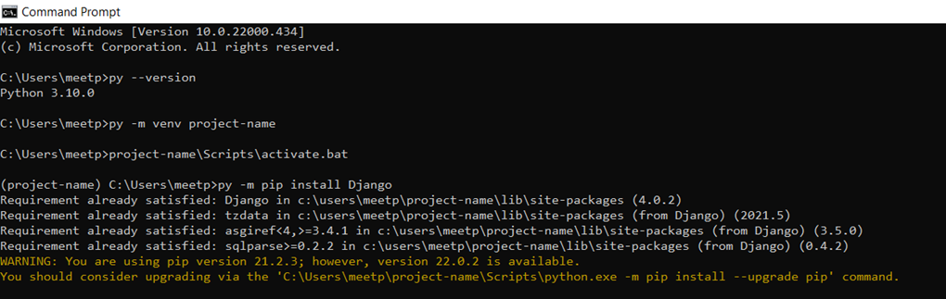

## Step : 2 create an environment

Step : 3 open visual studio , folder five (as per me ) in visual studio ,files will be uploaded

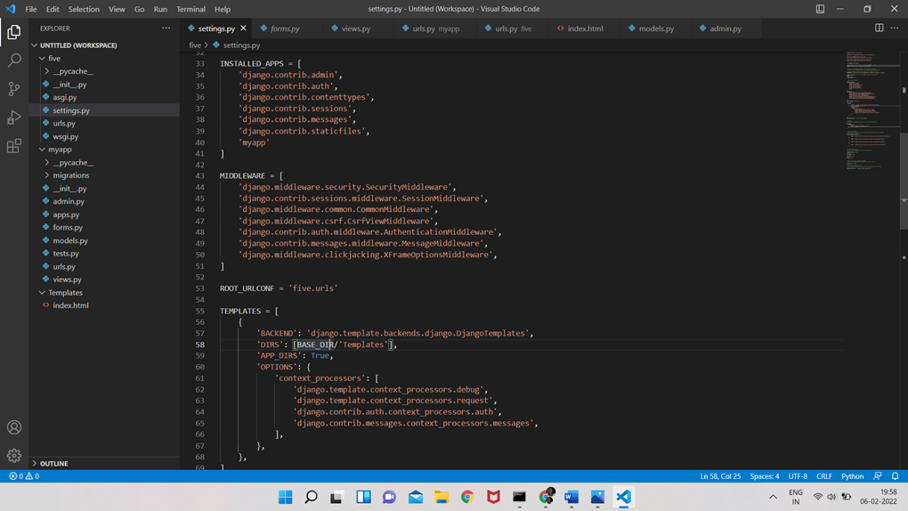

Step : 4 For execution of the form go to command prompt

type: python manage.py makemigrations

thereafter type: python manage.py migrate

after type:python manage.py runserver

we will get an ip address

copy that and paste it in chrome

add : /form to the address

<http://127.0.0.1:8000/form>

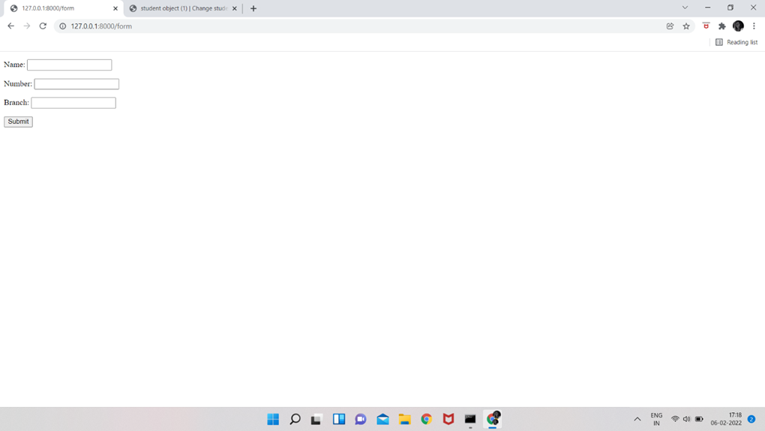

Step : 5 We will get a form like this

thereafter create a user id for dijango

by typing in cmd propmt : python manage.py createsuperuser

Step : 6 http://127.0.0.1:8000/admin with/admin

again go to chrome and paste the address

will get a site consist of username and passowed

will get an Django administration site

login

in student option we can cretae as many as student objects and we can delete too

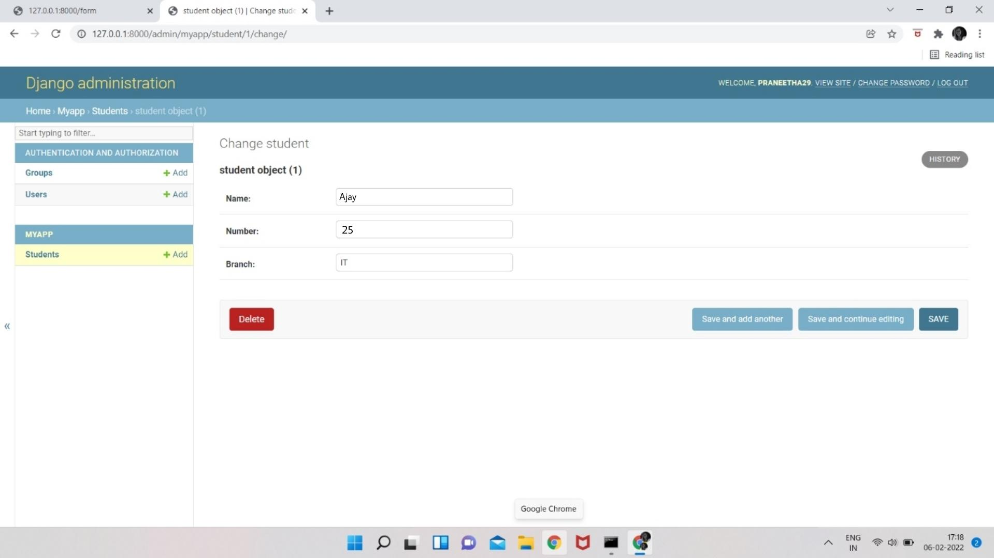

# **Week - 11**

## 1.CRUD operations on the form.

## CRUD Meaning: CRUDis an acronym that comes from the world of computer programming and refers to the four functions that are considered necessary to implement a persistent storage application: **create, read, update** and **delete**.

## 

|  |  |  |
| --- | --- | --- |
| **Letter** | **Operation** | **Function** |
| C | Create | Insert |
| R | Create | Select |
| U | Update | Edit |
| D | Delete | Delete |

CREATE:

## UPDATE

Step 1: Select and open one of the objects created.(say student object (1))

## 

Step 2: Select the Save and continue editing button to update the object

## DELETE

Step 1: Select the student object to delete.

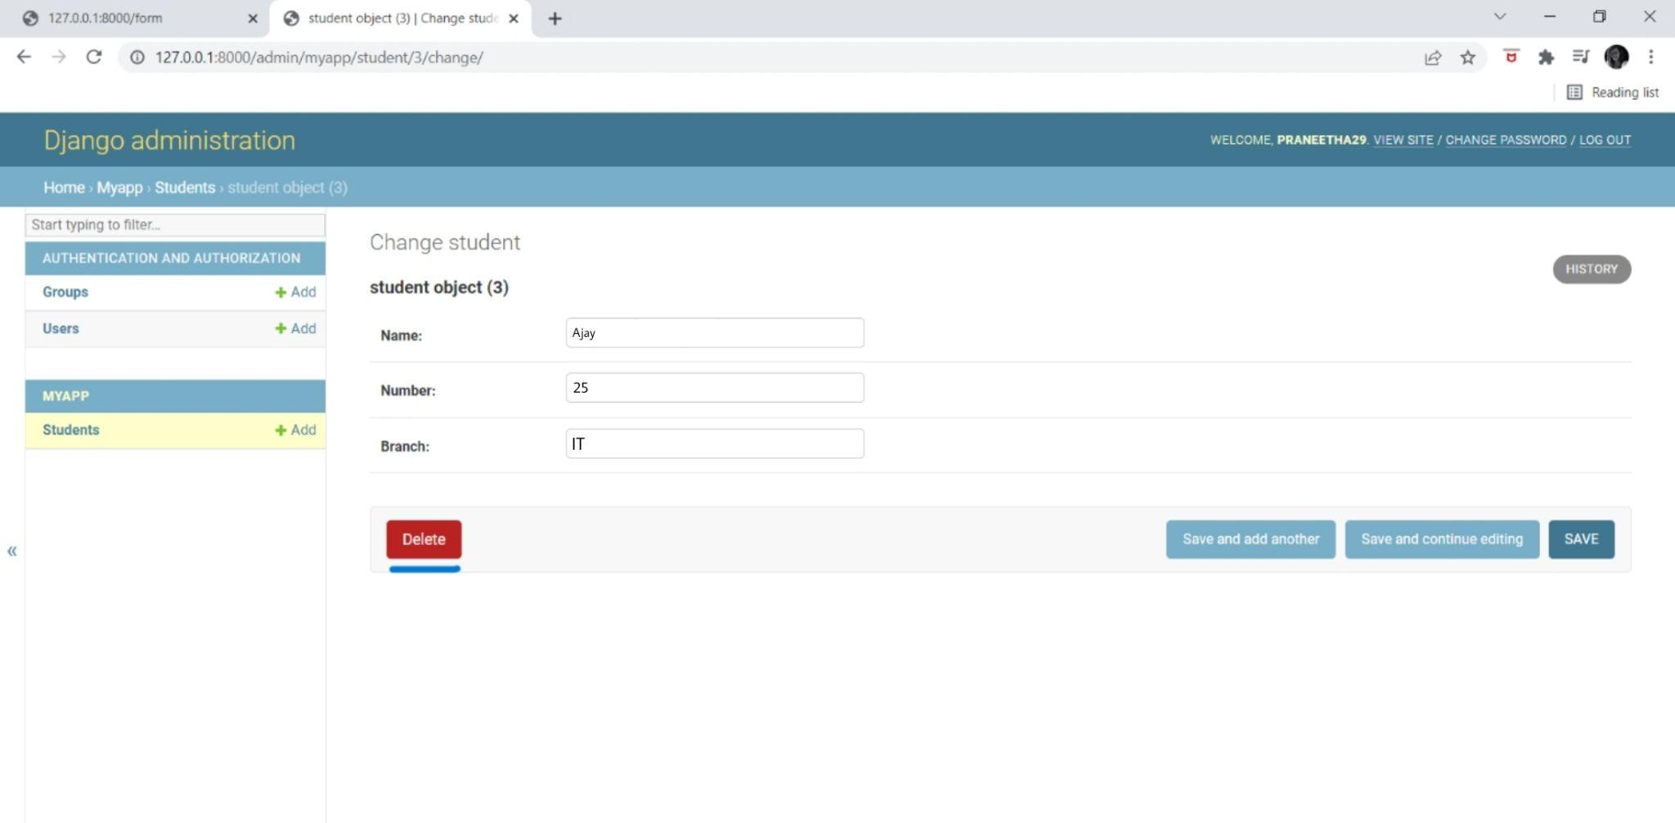

Step 2: The student “student object(3)” was deleted successfully.

